


DECLARATION OF PROJECT

Student’s Name | : | EMANUEL PRESTON A/L VINCENT
Student’s ID | : | BIT-B2201F_2409001 | :
Date of Birth | : | 13/9/2004 | :
Project Title | : | SMART BABY MONITORING SYSTEM USING IOT
I declare that this project report is classified as:
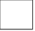☒ | OPEN ACCESS | I agree that my report to be published as a hard copy or made available through online open access.
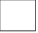☐ | RESTRICTED | Contains restricted information as specified by the organization/institution where research was done. (The library will block access for up to three (3) years)
☐ | CONFIDENTIAL | Contains confidential information as specified in the Official Secret Act 1972)
(If none of the options are selected, the first option will be chosen by default)

I acknowledge the intellectual property in the project belongs to Raffles University and I agree to allow this to be placed in the library under the following terms :
- This is the property of Raffles University
- The Library of Raffles University has the right to make copies.
- The Library of Raffles University is allowed to make copies of this project for academic exchange.
Signature of Student:
Signature:
Full Name
Date:
Approved by Supervisor(s)
Signature of Supervisor I: | Signature of Supervisor II
Full Name of Supervisor I | Full Name of Supervisor II
Date: | Date:

NOTES: If the project report is CONFIDENTIAL or RESTRICTED, please attach with the letter from the organization with period and reasons for confidentiality or restriction

Abstract
Babies are vulnerable to sleep-related hazards, including the risk of suffocation caused by soft bedding covering or obstructing their breathing area. This project focuses on developing a Smart Baby Monitoring System using Internet of Things (IoT) technology to help caregivers monitor a baby’s sleeping environment and identify potential soft bedding suffocation risks. A review of previous studies and existing baby monitoring systems was carried out to understand the main risk factors and identify suitable sensors and technologies for the proposed system. Based on these findings, an IoT-based monitoring system was designed and developed to monitor selected conditions around the baby during sleep. When the system detects a condition that may indicate a potential suffocation risk, it sends an alert to the caregiver. The developed system is evaluated through a series of tests to assess its functionality, ability to detect potential risks, and alert response time. The project aims to provide a simple and practical monitoring solution that can assist caregivers in creating a safer sleeping environment for babies.

Table of contents

Cover page 1
Abstract 2
Table of contents 3
List of tables 4
List of figures 5
List of symbols and abbrevations 6
1.0 Introduction 7
1.1 Project background--------------------------------------------------------------------------7
1.2 Problem statement-------------------------------------------------------------------------7-8
1.3 Project scope---------------------------------------------------------------------------------8
1.4 project objectives--------------------------------------------------------------------------8
1.5 Impact and contribution------------------------------------------------------------------
2.0 Literature review 10
2.1 Overview of Infant Sleep Hazards --------------------------------------------------10
2.2 Evolution of baby monitoring system----------------------------------------------10 - 11 2.3 Computer vision and AI usage-----------------------------------------------------------12
2.4 Previous baby monitoring system flaws and solutions--------------------------12-13
2.5 Current system weaknesses----------------------------------------------------------13-15
2.6 Proposed system-----------------------------------------------------------------------15
3.0 Methodology 16
3.1 Introduction………………………………………………………………………16
3.2 Methodology……………………………………………………………………17
3.3 Hardware………………………………………………………………………17
3.3.1 ESP32 CAM……………………………………………………………18
3.3.2 Camera module………………………………………………………18
3.3.3 Deployment……………………………………………………………19
3.4 Algorithm……………………………………………………………………19-20
3.5 How it achieves the objectives………………………………………………….20
4.0 Conclusion………………………………………………………………………………21
5.0 References……………………………………………………………………………….22

List of tables
1. Table 1: Proposed system vs other systems

List of figures
1. Figure 1: First baby monitoring system
2. Figure 2: locked with membership
3. Figure 3:ESP33 CAM
4. Figure 4: FTID PROGRAMMER
5. Figure 5: System Architecture

1.0 Introduction
1.1 Project background
The world currently uses modern technology everywhere we go and everything we touch and see is using the term IOT or Internet of Things. IOT is used almost everywhere from traffic lights to heartbeat monitors that track real time heart rates in medical facilities we see today. Not only we see it being used in high end areas but also in our homes that we live in everyday and mainly for our security such as cameras or more such like our loved ones like babies.
With the existing of IOT and technology, baby monitors were designed specifically for the parents to monitor the children’s behaviours in the room where they sleep. Furthermore, these baby monitors can detect crying, movements and many more. But all of these technologies may still prove to be fatal as every invention has a disadvantage to it.

1.2 Problem statement and motivation
Although with all of the current technologies implemented in the baby monitoring system, the term SBS (Soft Bedding Suffocation) is still on going until today. Soft bedding suffocation is where a baby is suffocated by anything soft like a blanket covering the baby’s breathing area and slowly cutting off the oxygen causing suffocation and then death. Babies as we know lack the motor controls to swat away the blanket from their faces unlike we adults do every time. To understand the meaning of lack of motor functions, The lack of motor functions means that babies don’t possess or have the ability to move the object that fell on top of them and this causes the baby to not respond to it and resulting in a fatal mistake.
In the United States, there were reports of soft bedding suffocation roughly 3,400 to 3,500 sudden unexpected infant deaths (SUID) each year [1]. To prevent this from happening as an IT student in this course I will be conducting my research and also implementing the necessary tools to invent a system that can combat this issue. the system that I’m developing called HappyBaby
1.3 Project scope
This project will use a camera module which is called esp32 with the camera module alongside using Arduino. The camera will be positioned on top of the crib and the camera will detect if there is a soft object on top of the baby.
Once there is an object on the baby, then the camera will detect the object on the baby like a blanket and then the parents will receive a notification on the phone app that informs the parents that theres an object on the baby.

1.4 Project Objectives
During the ongoing project. This project aims to create a working prototype using the current skills learnt during the course and hoping that it can be improved further for future deployment.
Moreover, this project aims to help and prevent or reduce the death of infants through soft bedding suffocation.
The goal of this project is to design and develop an IoT-based solution to help prevent soft bedding suffocation in babies by developing a system that can monitor and provide alerts to the parents if there is an object on the baby
In order to archive this goal, my objectives are:
1. to identify the components/function that the current systems are implementing in today’s smart baby monitoring systems. Moreover doing personal research on previous flaws or features that are not yet implemented
2. to design and implement an IoT-based monitoring system that detects potential soft bedding suffocation risks and provides real-time alerts to caregivers
3. to evaluate the effectiveness and functionality of the developed IoT solution in detecting potential soft bedding suffocation risks and providing alerts to caregivers.

1.5 impact and contribution
This project will prevent the death of infants by soft bedding suffocation and reduce the number of cases regarding soft bedding suffocation. This system directly mitigates Accidental Suffocation and Strangulation in Bed (ASSB) and sleep-related risks by offering a system that can instantly notify the parents.
Moreover, the system will prevent alert fatigue like in current systems where the system sends false alarms to the parents even such a small movement was done by the baby like pulling the blanket instead of actual soft material covering the baby’s face leading to suffocation.
The importance of this system helps with the primary issue which is soft bedding suffocation where as the system has a direct line of sight and the sensors will trigger when there is an obstacle on the infants and reducing the number of deaths. Moreover, this system will use a better sensors that is prioritized in detecting obstacles or anything on the baby and therefore sending an alert to the parents where as the current systems lacks the true alarm where the current system has a lot of false alarms and causing alert fatigue.

2.0 Literature review
2.1 Overview of Infant Sleep Hazards
Accidental Suffocation and Strangulation in Bed (ASSB) remains one of the leading causes of Sudden Unexpected Infant Death (SUID) in babies under 12 months. According to pediatric safety guidelines from the American Academy of Pediatrics (AAP),[2] keeping soft objects out of the crib is crucial. Heavy blankets, pillows, plush toys, and soft bedding can easily block an infant's airway. Because babies under six months haven't fully developed their motor skills or neck strength, they often can't turn their heads or push away a heavy blanket if it falls over their face. Without continuous supervision during sleep, prolonged airflow blockage can quickly turn dangerous.
2.2 Evolution of Baby Monitoring Systems
Baby monitors have come a long way from simple audio walkie-talkies to high-definition video feeds streaming directly to the parent’s phone. However, most standard video monitors are completely passive. They rely entirely on a parent constantly watching the screen to notice if something is wrong.
The first baby monitor that was invented was during the year 1937 called the zenith radio nurse, created by Eugene F. McDonald and designed by Japanese-American sculptor and product designer Isamu Noguchi[3]. This was the first ever product that has been created to ensure the baby’s safety although during that time it was expensive to the locals.

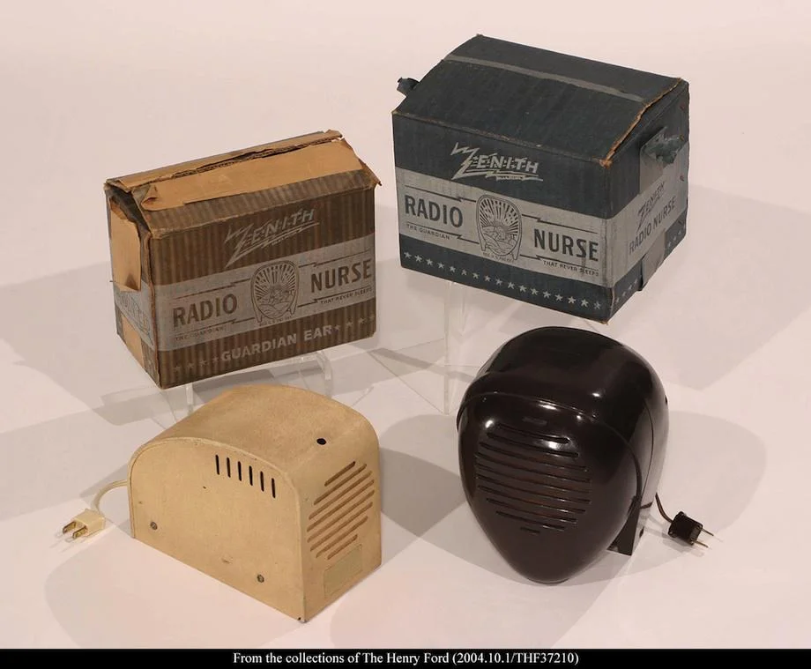
Figure 1: First baby monitoring system
Moreover, in the year 2015 and so on with the constant development and innovation of technologies along side with the constant development of artificial intelligence, baby monitors have been implemented with cloud based system providing real time data such as temperature, humidity, breathing and etc [4].

As time passed by and the technologies were getting more and more advanced, Newer video systems introduced pixel-based motion detection. The problem is that these cameras can't tell the difference between normal baby movements (like kicking or squirming) and actual danger. As a result, parents get flooded with constant false alarms every time the baby shifts in bed, leading to "alert fatigue" where they eventually start ignoring the notifications altogether.

2.3 Computer Vision and AI for Obstruction Detection
In the year of 2010, as technology and machine learning was becoming more advanced, Transfering learning techniques such as fine-tuning pre-trained models have become prevalent in computer vision the development of GPU’s were being invented to support the learning of the computer vision [5].
To automate safety checks, modern smart nursery cameras (such as Cubo AI or Nanit) started integrating computer vision (CV) and machine learning. These systems use algorithms like Convolutional Neural Networks (CNNs) or Haar Cascade classifiers to identify key facial landmarks—specifically tracking the baby's eyes, nose, and mouth. If these points disappear from view for too long, the system assumes the face is covered.

While this technology is a major step forward, current commercial products still have significant drawbacks. When soft bedding partially covers the baby's face, standard algorithms often lose track of the facial landmarks entirely. The camera struggles to distinguish between a baby simply turning their head away versus a blanket physically suffocating them.
2.4 Previous baby monitoring system flaws and solution
In March 2010 a 10-month old girl from Washington, D.C. strangled in her crib in the electrical cord of a Summer Infant video monitor. The monitor camera had been placed on top of the crib rail. In November 2010 CPSC received a report of a six-month old boy from Conway, S.C., who strangled in the electrical cord of a baby monitor placed on the changing table attached to the crib. In January 2011 CPSC learned the product involved was a Summer Infant video baby monitor [6].
CPSC and the firm are also aware of a near strangulation incident in which a 20-month old boy from Pittsburg, Pa. was found in his crib with the camera cord wrapped around his neck. The Summer Infant monitor camera was mounted on the wall, but the child was still able to reach the cord. He was freed from the cord without serious injury.
Summer Infant has initiated a campaign to provide new on-product labels for electric cords and instructions to consumers with the recalled video monitors distributed between January 2003 and February 2011. The baby monitors were sold at major retailers, mass merchandisers, and juvenile products stores nationwide for between $60 and $300. They were sold in more than 40 different models, including handheld, digital, and color video monitors. All video monitors include both the camera (placed in the baby's room) and the hand held device (some models have two hand-held devices) that enable the caregiver to see and/or hear the baby from a specific distance. The brand "Summer" is found on the product [6].

2.5 Current system weaknesses
Despite the current existing technologies, every system invention has a flaw or limitations towards it for example even the high end baby monitoring system records the heartbeat, temperature and movements and so on but the system still lacks the alarm systems such as notifications through a local server to send notifications to the parents signaling theres a problem.
Previous systems have alarms integrated into it but it was an effort that would be something annoying to the parents as the alarms will give false alarms. False alarm means that if theres even the smallest movements in the crib and the alarm flags it as a problem. In long term it will cause the parents to be frustrated and later ignoring the alarms blaring and sooner or later when the real problem arrives if theres a suffocation then the parents will ignore it as a faulty alarm and causing a fatal mistake.
Moreover, high end systems are required to pay a hefty monthly subscription to gain more access just to watch their baby and keep it safe from hazards. In an article highlighting a baby monitoring system called MIKU baby monitor which costed the buyer $400( RM 1630.30) to use it [7] [7]. Furthermore, the MIKU system has a “pay to be safe” feature where the user needs to pay extra for the subscription or else they can use the device. The article reports that users have to pay $9.99 (RM 40) a month just to enjoy extra features and to keep their baby safe [7].
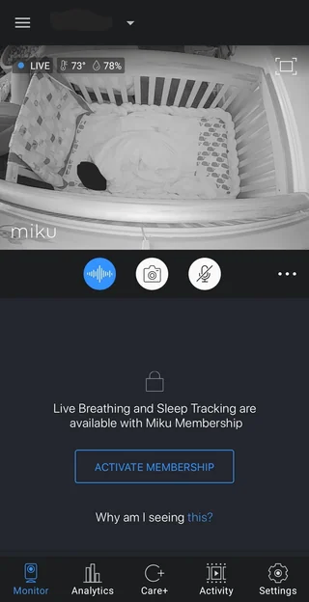
Figure 2: locked with membership

Furthermore, Miku doesn’t have a dedicated mobile app or monitor screen to run the system, instead the parents need to use their personal phones to monitor and in this case it will drain the phone battery and resulting in a blind monitoring as the system is dead and cant alert the parents or wake them up to notify them about the hazards going on.
System Category | Technological Approach | Key Strengths | Core Weaknesses / Gap
Traditional Video Monitors | IP / Wi-Fi Streaming | Continuous live video feed | Passive: Requires constant human eye contact; zero automated safety checks.
Basic Motion-Based Systems | Pixel-difference frame comparison | Detects physical movement | High False Alarms: Cannot distinguish normal sleep fidgets from actual danger.
Commercial AI Smart Cameras | Cloud-based CNN facial keypoint tracking | Automated alerts under optimal lighting | Expensive & High Latency: Requires $300+ hardware, cloud subscriptions, and fails during Wi-Fi drops.
Proposed IoT Vision System | On-Edge Computer Vision (OpenCV/Lightweight Model) | Low-cost, zero subscription, edge-processed for instant local/remote alert | Requires proper overhead camera positioning
Table 1: Proposed system vs other systems
3.0 Methodology
3.1 Introduction
Babies spend a lot of time sleeping, so making sure they have a safe sleeping environment is important. One of the possible risks during sleep is when a soft blanket or bedding accidentally covers the baby's face or upper body. If this happens, the caregiver may not notice it immediately, especially when they are not constantly watching the baby.
Most existing baby monitoring systems allow caregivers to watch their baby through a camera, but they still depend on the caregiver to notice when something is wrong. This means that the caregiver needs to continuously monitor the camera, which may not always be practical. With the development of IoT and computer vision technology, it is possible to make the monitoring process more automatic.
Therefore, this project proposes a Smart Baby Monitoring System using an ESP32-CAM and object detection. The camera will capture the baby's sleeping area, while the object detection system will identify the baby and detect potential obstructions such as a blanket covering the baby's face or upper body. When a potential obstruction is detected, a notification will be sent to the caregiver. The system will then be tested to determine how effectively it can detect potential obstructions and how quickly it can notify the caregiver.

3.2 Proposed methodology
The proposed project will use a camera-based IoT approach to develop a Smart Baby Monitoring System. An ESP32-CAM will be used to capture images of the baby's sleeping environment, while an object detection model will analyse the images to identify the baby and potential obstructions such as a blanket covering the baby's face or upper body. When a potential obstruction is detected, the system will send a real-time notification to the caregiver

3.3 Hardware
3.3.1 ESP32 CAM
The ESP32-CAM will be the main hardware component of the system. It has a built-in camera that allows it to capture images of the baby's sleeping area. The ESP32 also provides Wi-Fi connectivity, which can be used to send information or trigger notifications when a potential obstruction is detected
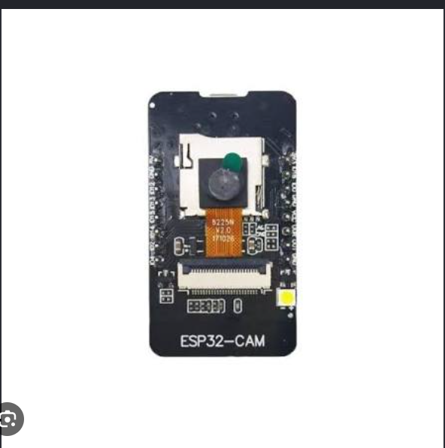
Figure 3:ESP33 CAM
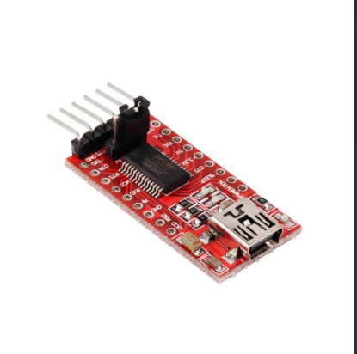
Figure 4: FTID PROGRAMMER
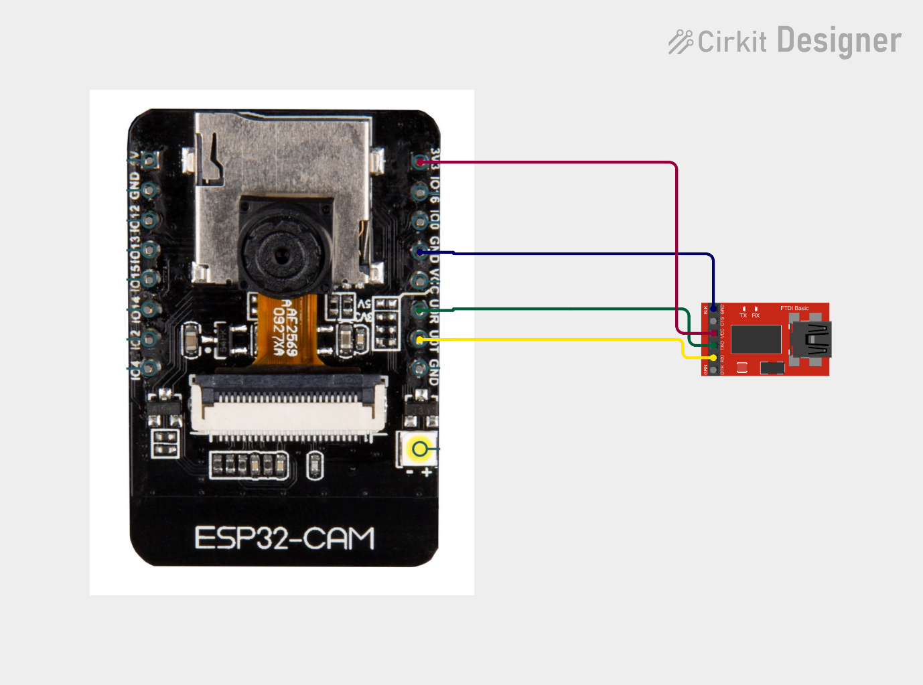
Figure 5: System Architecture

3.3.2 Camera module
The camera module on the ESP32-CAM will be used to capture images or video of the baby during sleep. The camera should be positioned so that the baby's face and upper body can be clearly viewed. This allows the object detection system to identify potential obstructions, such as a blanket covering the baby.
3.3.3 Laptop for deployment
A laptop will be used during the development stage to train, test, and evaluate the object detection model. The model can then be integrated into the monitoring system depending on the selected implementation approach.

3.4 System algorithm
START
↓
Initialize ESP32-CAM
↓
Connect to Wi-Fi
↓
Start Camera
↓
Capture Video Frame
↓
Run Object Detection
↓
Is Blanket Detected?
↓
┌───────────────┐
│ │
NO YES
│ │
↓ ↓
Continue Check Detection
Monitoring Duration
↓
Detected Long Enough?
↓
┌──────┴──────┐
│ │
NO YES
│ │
↓ ↓
Continue Send Notification
Monitoring ↓
Continue Monitoring

3.5 How does it achieve the objectives
A review of literature and existing baby monitoring systems will be carried out to understand soft bedding risks and investigate existing camera-based monitoring and object detection approaches. This will help determine the requirements for the proposed system.
Based on the findings, an ESP32-CAM will be used to capture the baby's sleeping environment. An object detection approach will be implemented to identify the baby and potential obstructions, such as a blanket covering the baby's face or upper body. When a potential obstruction is detected, the system will send a notification to the caregiver.
The developed system will be tested using different scenarios to determine how effectively it can detect potential obstructions. The evaluation will consider factors such as detection accuracy, false detections, and notification response time.

4.0 Conclusion
In conclusion, this project focuses on developing a Smart Baby Monitoring System using the AI-Thinker ESP32-CAM to help caregivers monitor their baby's sleeping environment. The system will use a camera and object detection to identify potential blanket obstructions and send a notification to the caregiver when one is detected. The project will also involve reviewing existing studies and monitoring systems to identify suitable methods for developing the proposed system. After development, the system will be tested to see how accurately it can detect blanket obstructions and how quickly it can send notifications. Overall, this project aims to provide a simple and practical way to help caregivers be more aware of potential risks during a baby's sleep. However, the system is intended to support caregivers and should not replace proper supervision or safe sleeping practices.

5.0 References
https://pmc.ncbi.nlm.nih.gov/articles/PMC6637427/
.https://publications.aap.org/pediatrics/article/150/1/e2022057990/188304/Sleep-Related-Infant- Deaths-Updated-2022?autologincheck=redirected
Parks-Brown, S et al. Pediatrics. 2022;doi: 10.1542/peds.2022-057771
https://safetosleep.nichd.nih.gov/resources/social-digital/accidental-suffocation-and-strangulation-during-infant-sleep-text-alternative
https://www.cdc.gov/mmwr/volumes/74/wr/mm7419a2.htm
https://ieeexplore.ieee.org/abstract/document/8760478
https://iecscience.org/jpapers/25
https://www.researchgate.net/publication/369947942_IoT_Based_Smart_Baby_Monitoring_System_with_Emotion_Recognition_Using_Machine_Learning
https://www.nature.com/articles/s41598-025-02691-8
https://www.hellobaby-monitor.com/blogs/news/when-were-baby-monitors-invented?srsltid=AU7gw4VAI2e5voNCe1lnke-HXkU4SzanUoWmUlqNiMIFjWCnGLgtVnC6
https://medium.com/@ambika199820/what-is-computer-vision-history-applications-challenges-13f5759b48a5
https://www.ijprems.com/ijprems-paper/iot-based-baby-monitoring-system-for-smart-cradle-a-comprehensive-solution-for-infant-care
https://pmc.ncbi.nlm.nih.gov/articles/PMC12125208/#CR3
https://www.cpsc.gov/Recalls/2011/two-strangulation-deaths-prompt-summer-infant-to-recall-video-baby-monitors-with-cords
https://www.theregister.com/offbeat/2023/10/06/400-baby-monitor-vendor-demands-monthly-subscription/1005443
https://www.cbsnews.com/sacramento/news/call-kurtis-investigates-expensive-baby-monitor-switches-to-subscription-model-parents-are-ticked/

